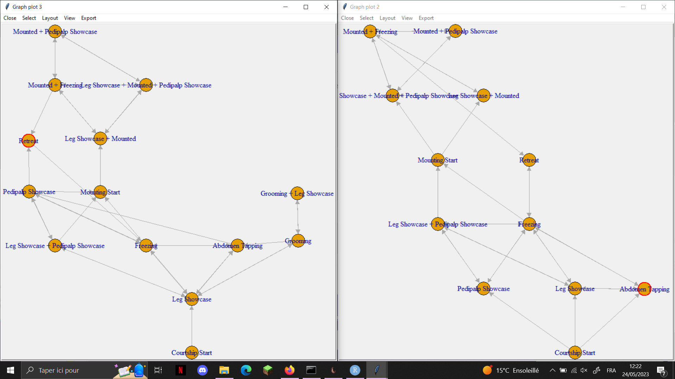

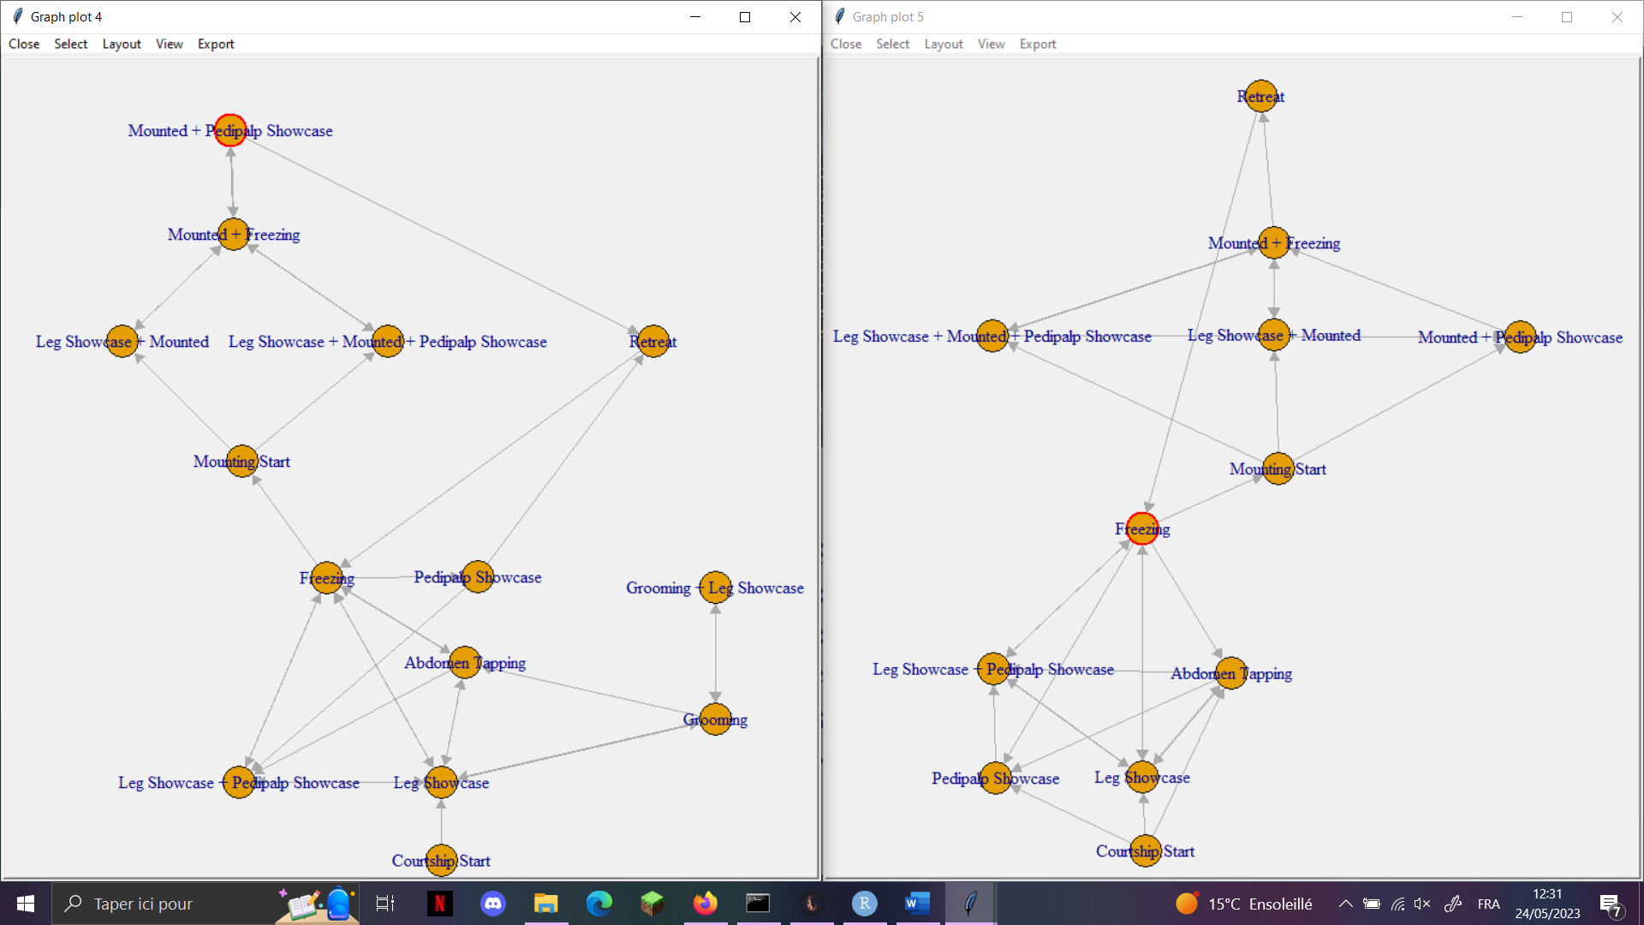

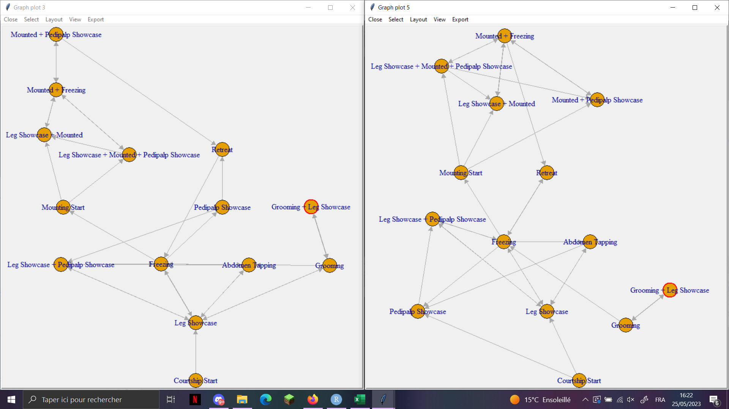

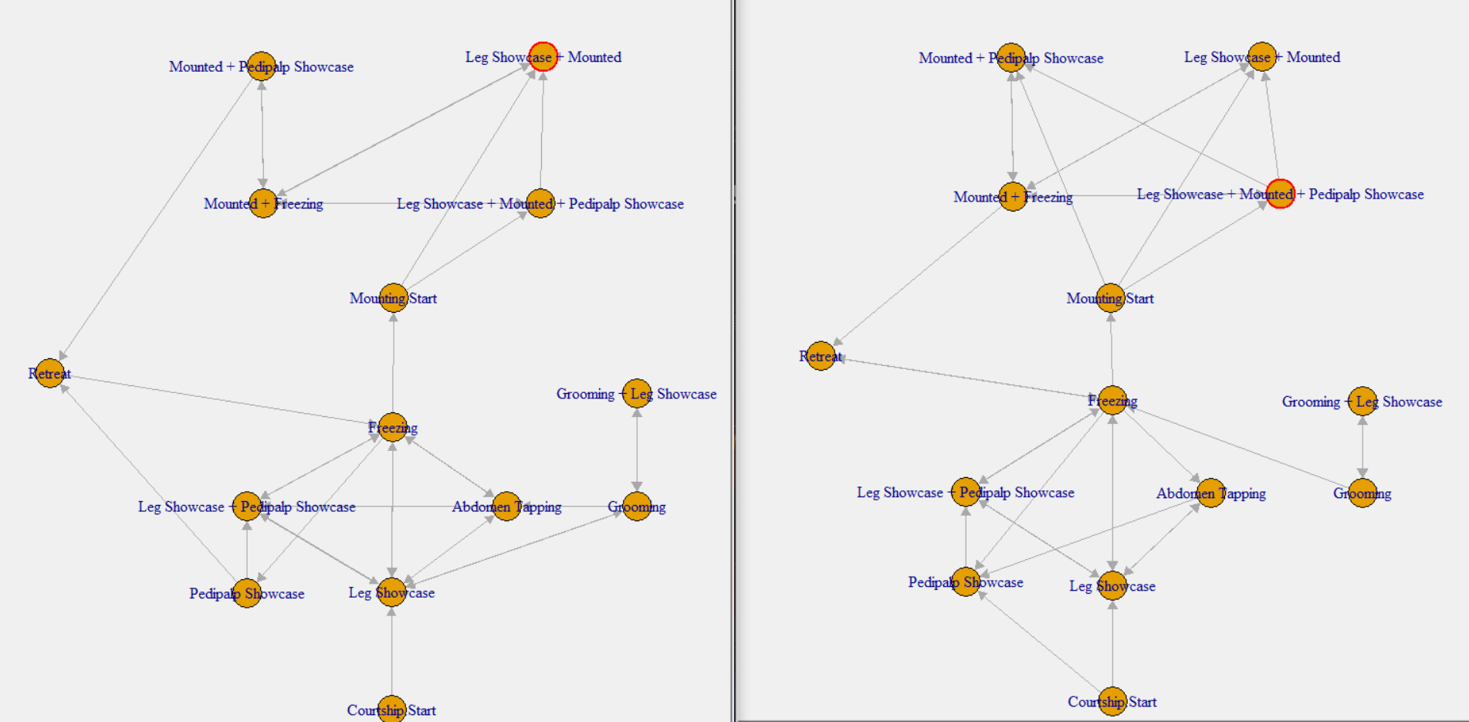

|  |  |  |  |  |  |
| --- | --- | --- | --- | --- | --- |
|  |  |  | Response variables | | |
|  |  |  | Latency to mount | Latency to attack | Latency to copulate |
|  |  |  |  |  |  |
| Explanatory variables | Total courtship duration |  | χ² = 0.75; df = 1; P = 0.39 | χ² = 0.77; df = 1; P = 0.38 | χ² = 0.29; df = 1;  P = 0.59 |
| Number of courtship attempts |  | χ² = 0.08; df = 1; P = 0.77 | χ² = 2.65; df = 1; P = 0.10 | χ² = 0.05; df = 1;  P = 0.82 |
| Mean duration of courtship attempts |  | χ² = 0.94; df = 1; P = 0.33 | χ² = 1.52; df = 1; P = 0.22 | χ² = 0.29; df = 1;  P = 0.59 |